8.43: a) In Eq. (8.24), let 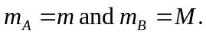 Solving for M gives
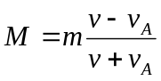
In this case, with the minus sign indicating a rebound. Then, 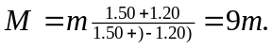 Either Eq. (8.25) may be used to find 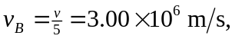or Eq. (8.23), which gives the same result.

